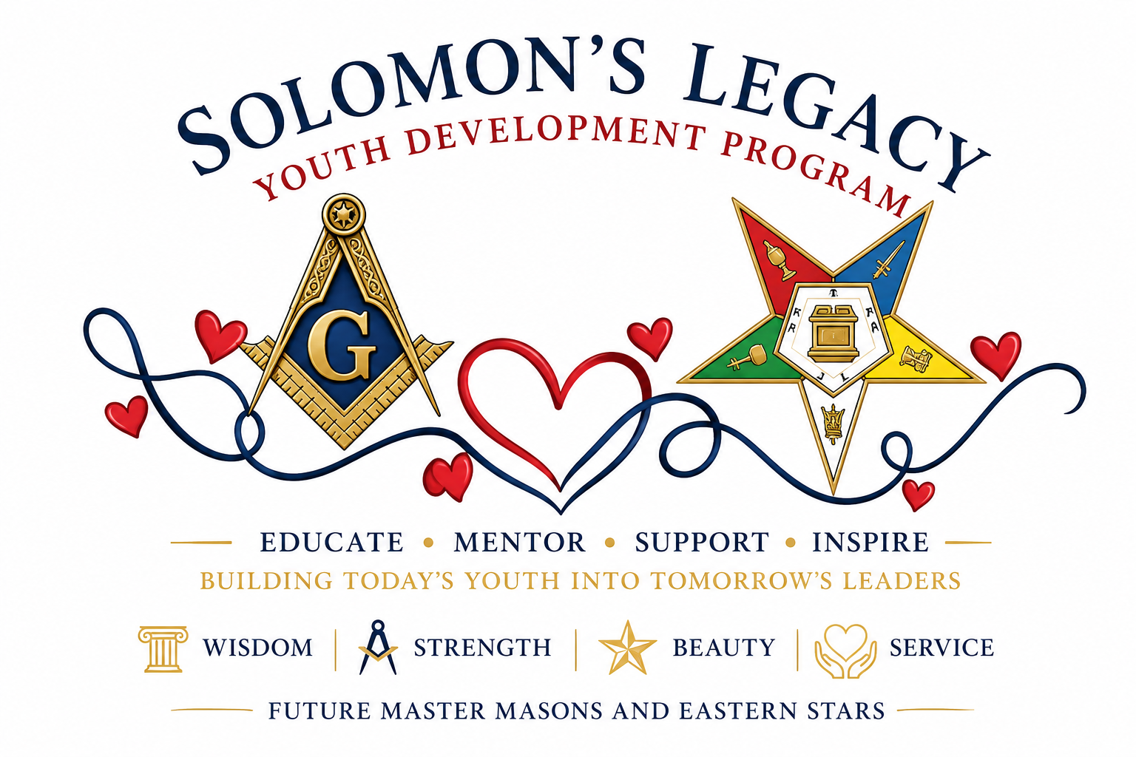

Purpose
The Solomon's Legacy Youth Development Program is a nationwide initiative established to educate, mentor, support, and inspire the youth of our Order. Through intentional guidance, meaningful engagement, and dedicated investment, this program seeks to prepare young men and women to become productive citizens, compassionate leaders, and future Master Masons and Eastern Stars who exemplify the timeless principles of Wisdom, Strength, Beauty, and Service.”

Program Overview
The Ill. Layton Swinney Supreme King Solomon's and Patron's Council, in keeping with the highest ideals of Freemasonry and Eastern Star, proudly dedicates its membership, leadership, and resources to a unified national service initiative focused on the development and advancement of our youth.
It has often been said that "Charity begins at home." The International Free and Accepted Modern Masons, Inc. (IFAMM) is our home, and the Supreme Youth Department represents not only a vital part of that home but also the future strength, leadership, and continuity of our beloved Order. Recognizing this responsibility, we have chosen to invest our charitable efforts where they can have the greatest and most lasting impact—within our own Youth Department.
Through this initiative, the Supreme, National, and Grand King Solomon's Councils will partner with their respective Supreme, National, Grand, and Local Youth Departments to provide support, encouragement, and opportunities for growth and development.

Areas of Support
Support provided through the Solomon's Legacy Youth Development Program may include, but is not limited to:
- Assisting and enhancing existing Youth Department programs, projects, and initiatives
- Sponsorship of youth memberships and convention participation
- Leadership development and character-building programs
- Mentorship opportunities for young adults
- Educational enrichment resources
- Scholarship, educational grant, and book voucher opportunities
- College student and military service member care package programs
- Career exploration, networking, and professional mentorship
- Masonic and Eastern Star transition and bridging sponsorships
- Development of innovative programs designed to strengthen, grow, and retain youth membership
- Community service and civic engagement opportunities
- Recognition programs celebrating youth achievement and excellence

Our Commitment
As Princes of the King Solomon's Council, we symbolize the Wisdom that God bestowed upon King Solomon. That divine wisdom teaches us that the future of IFAMM depends upon our willingness to cultivate, mentor, and prepare the next generation of leaders.
If our Order is to continue to flourish, we must intentionally invest in our youth today so that they may confidently assume their place tomorrow. This responsibility is not merely an obligation—it is a sacred duty entrusted to us by the principles we profess and the oath we have taken.
Through the Solomon's Legacy Youth Development Program, we pledge to encourage growth, inspire excellence, foster leadership, and help build a lasting bridge between our Youth Departments and the future of Freemasonry and Eastern Star.
Together, we will preserve our legacy by investing in those who will one day carry it forward.

Fraternally Submitted,

Prince Karon L. Wheeler
Supreme King Solomon
Ill. Layton Swinney Supreme King Solomon’s and Patron’s Council

