King Solomon Memorial Ceremony
Procession
- 3 gavel raps to stand the room
- Organist will play “Soon and Very Soon”
- King Solomon enters and walks to the east and goes behind the Altar
- King Solomon lights the three candles.
- Oziel, the Chaplain and the Recording Secretary, will walk down the aisle towards the Altar in this order.
- At the Altar, Oziel will turn and go to the right side of the Altar, the Secretary will turn left and go to the left of the Altar, the Chaplain will turn right and go to the right of the Altar
- Queen Bathsheba, carrying the Rose, on the right, and Queen of the South, carrying the Scroll, on the left, will walk side by side down the middle aisle and will part once they reach the Altar. Queen Bathsheba goes to the right, and Queen of the South will go to the left.
Official Music

“Soon And Very Soon”
Andre Crouch

“Tomorrow”
The Winans

He’ll Welcome Me
New Line Community Choir feat John P. Kee
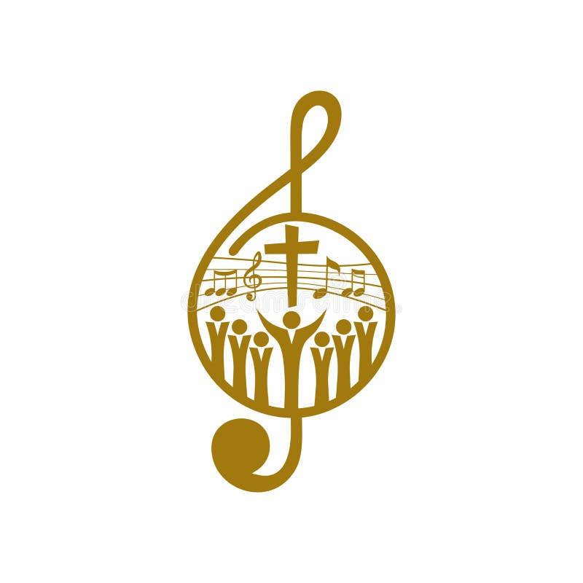

Line up in the East
Grand King Solomon
Queen of the South - Secretary 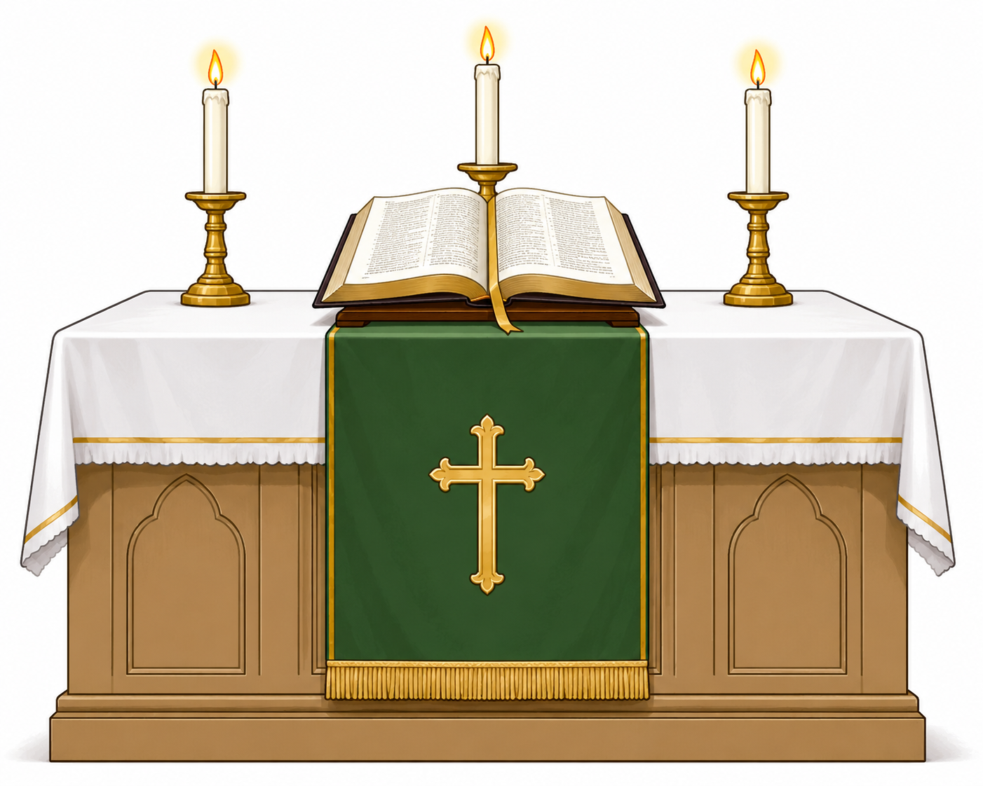 Oziel - Chaplain - Queen Bathsheba

This is the lineup as they face the West
Items Needed
- Altar
- Gavel
- 3 Candles / Lighter
- Bible (opened to John 14:1)
- White and/or Green Altar Cloth
- List of deceased (Sorted by State, District, or Council)
- 1 Scroll
- 1 Rose

Officers Needed
King Solomon's Council
- King Solomon - Cain
- Oziel - Harden
- Recording Secretary - Coy
- Chaplain - Jackson
Queen of the South Palace
- Queen Bathsheba
- Queen of the South
Organist

The Ceremony
King Solomon:
“King Solomons, Queen Bathshebas, Princes and Princesses. We are gathered here today to pay tribute and mourn our departed Kings.”

Oziel:
“Most Excellent King Solomon, may I be permitted to speak on behalf of our departed Kings?”

King Solomon:
“Speak Oziel.”

Oziel:
“I will take the cup of salvation and call upon the name of the Lord. Precious in the sight of the Lord is the death of His saints.”

Secretary:
In my hand, Most Excellent King Solomon, I mournfully carry the names of the departed.”

King Solomon:
“Speak their names.”

Secretary:
“As I call your (State, District, or local Council), please stand in honor of your departed kings.”
The Secretary will read the names of the departed Kings.

King Solomon:
“Tell us, Queen of the South, why have you traveled so far, and what are your gleanings of our departed Kings?

Queen of the South:
“Most Excellent King Solomon, remember, in First Kings, chapter 10, verses 4-5, all Israel heard of the king's judgment and honored him, for they saw that God had blessed him with wisdom to lead, discern, and administer justice with righteousness. I place this Scroll of Wisdom, representing the wisdom God has bestowed upon King Solomon.“

King Solomon:
“Tell us, Bathsheba, Mother and Queen, what are your gleanings of our deceased Kings?”

Queen Bathsheba:
“Truly, Most Excellent King Solomon, our departed Kings will be missed by all the Princesses. If it were not so, I would not have told you. We know that the deepest sorrow to man is the loss of his mother. But the deepest sorrow to a Mother is the loss of her son. I place this Rose on the Altar to symbolize the love of our departed Kings.”
King Solomon:
Takes two steps back (squares corner), walks behind Oziel and Queen Bathsheba,
(square corner), walks to the front of the Altar (squares corner), picks up the Bible (squares
corner), turns towards the audience and begins to read John 14:1-6:

“Let not your heart be troubled; you believe in God, believe also in Me.
In My Father’s house are many mansions; if it were not so, I would have told you. I go to prepare a place for you.
And if I go and prepare a place for you, I will come again and receive you to Myself; that where I am, there you may be also.
And where I go you know, and the way you know.”
Thomas said to Him, Lord, we do not know where You are going, and how can we know the way?
Jesus said to him, I am the way, the truth, and the life. No one comes to the Father except through Me.”

King Solomon returns the Bible to the Altar and returns to his place behind the altar, squaring corners.

Queen Bathsheba and Queen of the South take a step forward.

Organist begins to play “Tomorrow” (first verse and chorus only).

Queen Bathsheba and Queen of the South step back into line.

3 gavel raps

King Solomon:
“Chaplain, give us a Prayer of Comfort.”

Chaplain steps forward to offer a prayer of comfort and steps back in line when done.

Organist plays “He’ll Welcome Me”

Procession exits side by side and lines up in the back, leaving a space in the middle for King Solomon.

King Solomon
- Blows out the candles.
- Walks around the Altar and down the aisle to the middle of the procession in the back.
- Kings will say “So Mote It Be” 3xs (Queens will say “So May It Be”)
- He says, “This concludes the King Solomons Memorial Ceremony.”

